NEWSLETTER NO. 2

OCTOBER 2015

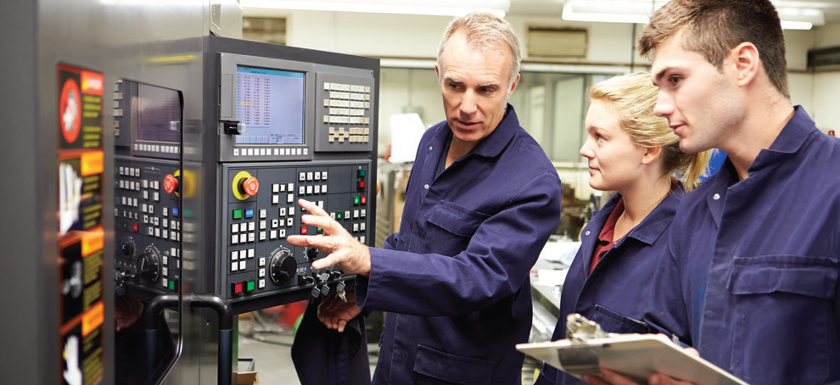

www.gzs.si/skill-me

skillME PROJECT

The Skills in Metal and Electro Industry or skillME project is a three-year collaborative project between vocational education and training (VET) providers, national regulatory partners and representatives of the metal and electro industries of the EU member states Croatia, Latvia, Slovakia and Slovenia, which aims at identifying the most endemic skill gaps in the metal and electro industries and developing four curricula to fill those gaps.

The project lasts from November 2014 until October 2017 and is co-founded by the Erasmus+ Programme of the European Union.

 LATEST NEWS

Following the project kick-off meeting in Ljubljana, Slovenia on 20 January 2015, skillME partners met for the second time at the second project meeting in Riga, Latvia on 15 July 2015.

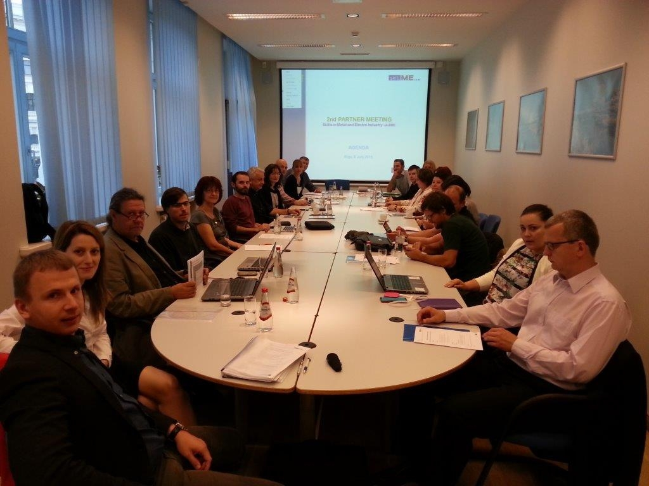

The purpose of the meeting was to discuss the progress of the project, to construct a framework for the upcoming project activities and to present the outputs created so far in the project.

WHAT HAS BEEN DONE SO FAR?

In order to help improve employability of future workers, raise the employability rate and improve the overall competitiveness of the European metal and electro companies, market players have long recognized the need to improve competencies of workers so as to correspond to current market needs and enhance knowledge in the industry.
The skillME project set out to identify the most pressing and wide-spread skill gaps in the industry of today and tomorrow and to design tools to help fill those gaps.

In the first project phase, partners analysed existing data in the field of skill gaps research in order to gain insight into the scope of the issue and form a starting point for further activities. The findings were further explored and upgraded with focus group and interviews with metal and electro companies from project countries.

The results gave a clear picture as to the most sought-after competencies and the most endemic skill gaps in the metal and electro industry today.

RESULTS

The analysis of international studies, scientific publications, expert opinions, relevant data sources and other existing data on skill gaps in the metal and electro sector did not reveal any precise data on specific skills that were missing in the sector. However, the studies did confirm that skill gaps are observed in various fields, from technical and managerial skills to work culture.

As this menat that the skill base to choose from was very wide, project partners decided to narrow the field and focus mainly on technical skills rather than soft skills in their endeavour to identify the most endemic skill gaps as technical skills allow for a more focused approach and are also more substantial in the electromechanical sector in the long term compared to soft skills.

To evaluate hard skill shortages in the metal and electro industry, focus group discussions and interviews were conducted with various representatives of ME companies of different sizes from participating countries. The main focus was to find skill gaps that are observed across the entire industry, not just in specific sectors or even at the level of individual companies.

Within successive activities of desk research, focus groups and interviews, a large amount of different skills, competencies and knowledge were identified in industries, as well as existing gaps in the current educational offering therein. By arranging these various skills by their significance in all partner countries, a list of the most significant skills whose gaps were identified by respondents of focus groups and interviews were obtained.

The research carried out in the project showed that the most common skill gaps in the metal and electro industry are observed in the field of:

1. TECHNICAL DOCUMENTATION
2. CAD/CAM SYSTEMS
3. AUTOMATISATION
4. NEW MATERIALS

The skill gaps identified are not only expressed in the labour market at present, but will most likely play an important part also in the future.

Although the project focuses on the development of hard skills and technical skills, it is not always possible to clearly distinguish their importance from soft skills, which is why a complex development of both is particularly essential. The improvement of hard skills will only be effective if we work on soft skills at the same time.

„A number of drivers of change are acting in unison to change skill requirements in a range of jobs. These include the increased use of technology, new materials and new processes throughout industry, an increasing emphasis on customers and meeting their requirements, new working practices, and the globalisation of many aspects of business. These demand higher-level skills and education, and also greater breadth of skill and greater flexibility in the applications of skills.”

Source: Connor H. et al. An Assessment of Skill Needs in Engineering. A Comprehensive Summary From Employers Of Skills Requirements In Engineering. The Institute For Employment Studies, 2000.

UPCOMING ACTIVITIES

In the next phase, project partners will narrow the scope of identified fields of skill gaps and prepare grounds for the creation of curricula which will fill those skill gaps. The curricula will be designed in a way that students as well as workers will be able to participate in them and aquire new knowledge.

The next project meeting will be held in Zagreb, Croatia on 8 and 9 December 2015.

- PROJECT PARTNERS

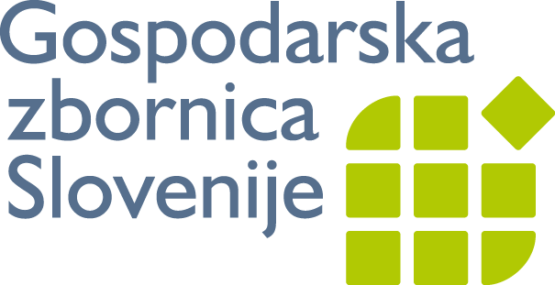
Metal Processing Industry Association

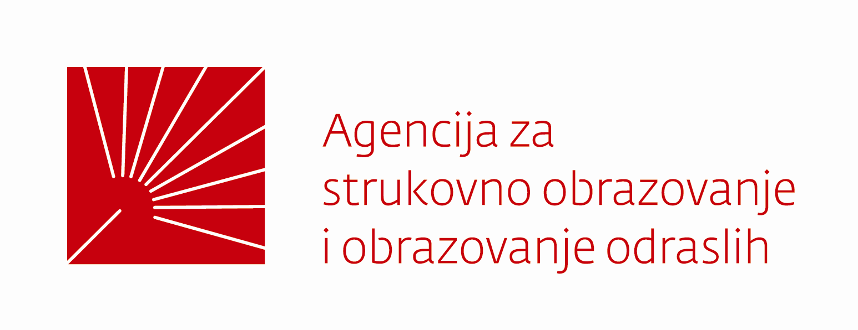

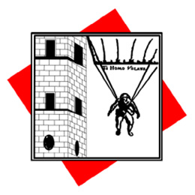
STROJARSKA TEHNIČKA
ŠKOLA FAUSTA VRANČIĆA

